

**Unemployment and the conduct of monetary policy in the UK**

Speech given by

Ben Broadbent, Deputy Governor for Monetary Policy, Bank of England

At the Federal Reserve Bank of Kansas City 38th Economic Symposium, Jackson Hole, Wyoming

23 August 2014

I would like to thank Alina Barnett and Richard Windram for research assistance and I am also grateful for helpful comments from other colleagues. The views expressed are my own and do not necessarily reflect those of the Bank of England or other members of the Monetary Policy Committee.

It is now almost half a century since Milton Friedman’s presidential address to the AEA. Yet it must still count as the single most influential paper about the conduct of monetary policy.

It didn’t hurt – it didn’t hurt Friedman’s case, that is – that, within only a few years, inflation had risen significantly. This was particularly true in the United Kingdom where, despite higher unemployment, CPI inflation and nominal wage growth rose to over 25% in 1975 (Chart 1).

Rapid inflation had effects far beyond the way monetary policy was run. Coupled with a rapid deterioration in the budget deficit, it made it increasingly difficult to fund the UK’s external balance; this led, the following year, to the necessity of IMF support. The government duly lost the next general election.

The inflation of the 1970s also shook to the core the belief that output was determined solely by aggregate demand and that supply constraints only ever applied in some far-off “long run”. Inverting Keynes’s famous aphorism, William Simon, US Treasury Secretary in the Ford administration and closely involved in the UK’s negotiations with the IMF, said this: “It’s Keynes who is dead and now we’re stuck with the long run”.

But the implications for the conduct of monetary policy were equally profound. The basic lesson that policy was, in the end, neutral, and should restrict itself primarily to some nominal target – Friedman had suggested that any of “[the] exchange rate, the price level and the quantity of a monetary total” would do – was accepted.

In fact, in Britain we were apparently so enamoured of his suggestions that we then proceeded to try all three. Targets for broad money growth were introduced in 1976 and, in one form or another, lasted until 1987. The government then began covertly to stabilise the exchange rate – a policy later known as “shadowing” the Deutschmark – and, in 1990, sterling formally entered the European Exchange Rate Mechanism. When that two-year experiment proved only a little more successful than Britain’s return to gold, seventy years earlier, we eventually settled on an inflation target.

And at no point during this journey was it suggested that any real variable should have equal status to the nominal objective. After the inflation of the previous few years, the very idea that monetary policy might be used to “manage demand”, on an ongoing basis, was anathema.

If that was true of real things in general, it applied that much more strongly to unemployment, because here there seemed to be the added problem that the level you might want to aim for – the natural rate – wanders about over time. Chart 1 plotted the bare numbers for unemployment and wage growth. Chart 2 does the same but subtracts from wage growth a measure of inflation expectations, based first on a model and then on the spread between the yields on conventional and indexed government bonds1. You can see that, at

1 Yields on indexed bonds, and the spread to those on conventional bonds, are available from the mid-1980s. Taking account of the empirical relationship between the two after that date, the inflation expectations series before that is constructed by the National Institute for Economic and Social Research.

least until the early 1990s, it’s hard to make out any sort of Phillips curve relationship even on an “expectations adjusted” basis.

This is not to say the authorities didn’t care about real economic outcomes. It was because they did so that sterling left the ERM. Though clearly junior to the inflation target – they were to be pursued only “subject to” price stability – the mandate for the newly independent Monetary Policy Committee, in 1997, said the MPC should also concern itself with “the government’s objectives for growth and employment”.

And under inflation targeting, UK monetary policy has, in fact, been responsive to real developments. At least until the financial crisis, there was a very close correlation between short-term interest rates and economic growth. Chart 3 is one way of representing this relationship. The blue line is a survey-based measure of private-sector GDP growth; the red line isn’t actual changes in official interest rate but, as a smoother proxy for those changes, the average vote on the Monetary Policy Committee.

Controlling for output growth, however, there is little else that seemed to matter for policy. In particular, there has been no identifiable response, at the margin, to labour market developments.

What I want to do in this talk is to explore why that was the case; why then, in 2013, the MPC then chose to condition policy explicitly (if loosely) on unemployment, in the initial phase of forward guidance; and how things have progressed since then. I will finish with some more general observations.

# A stable Phillips curve?

As I say, given the apparent volatility in the natural rate of unemployment during the 1970s and 1980s, it’s perhaps understandable that the monetary authorities should pay little attention to the labour market. But as unstable as the unemployment/inflation relationship had been prior to the early 1990s, what’s striking is how stable it has been since then. Chart 4a plots unemployment against expectations-adjusted wage growth, using annual data between 1993 and 2012. The R2 is 0.8.

In fact, not only is it stable within this sample, the relationship is also remarkably similar to the one that Phillips himself identified in the period from 1861-1913, the last half-century of the classical gold standard.

As he discovered, this was the only period in the pre-1957 data over which a reliable relationship between unemployment and wage growth had existed. After the start of the First World War, and the suspension of the gold standard, it broke down. He attributed this to shifts in sterling import prices, as if the exchange rate could somehow be considered independently of domestic monetary policy. Friedman said it was the result of volatile inflation expectations.

At any rate, in Chart 4b the dots for the 1861-1913 period have been added (in blue) to those from the post-1992 sample. We can’t formally adjust them for movements in inflation expectations. With the price level pinned down by the real value of gold, however, it’s probably reasonable to assume that inflation

expectations were relatively stable and, on average, close to zero2. So it seems to be the case that both the intercept and the slope of this line are very close to those that prevailed 100-150 years ago. The two fitted lines are statistically indistinguishable.

We should not draw too strong a conclusion from what is, arguably, just one independent observation. Nor is there only one interpretation of what the wage-unemployment relationship represents. In classical economics it’s an inverted short-run labour-supply curve. In some Keynesian models3, including those used by some central banks, it’s the result of some wage bargaining process, in which unemployment is the “disciplining device” that ensures that actual and warranted real pay growth are in line. Under this approach, the relationship in Chart 4a can be written as

w· - 兀e = {3(U∗ - U) + g

c

where w· is nominal pay growth, 兀e expected CPI inflation, U∗ the natural rate of unemployment and the intercept g̅ some employee “norm” for real pay increases. Unit cost growth for firms, expressed in consumer prices, is w· - g∗, where g∗ = y + 兀Y - 兀c is the warranted level of real pay growth (the sum of underlying productivity growth y and terms of trade gains for consumers – i.e. the rate of decline in real consumer prices).

c

Inflationary pressure therefore develops – unit costs accelerate – if unemployment falls below the “short-run NAIRU” (as distinct from the natural rate of unemployment), defined as

U∗∗ = U∗ + (g̅ - g∗)/{3

This could happen either in response to a pure increase in demand, depressing the actual level of unemployment; it could also happen if, for given unemployment, a hit to warranted real wages – from lower productivity, for example, or via a reduction in the terms of trade – isn’t immediately accepted by workers (i.e. if g∗ falls but there is no matching decline in g̅). So, at least in the short run, there’s a degree of resistance in real pay, implying that negative supply disturbances are inflationary.

2 Gold discoveries kept pace with growth in the demand for currency in the gold standard countries over that 50-year period and,

*ex post*, realised inflation averaged 0.1% a year. This doesn’t mean that *expected* inflation was always zero – gold discoveries were intermittent, and if they were also unanticipated, people would presumably have expected a degree of deflation over time (Eichengreen and Sussman (2000)). But the assumption that expected inflation was zero – that the best guess for the real price of gold tomorrow is the real price of gold today – probably isn’t a bad approximation.

3 The key assumption of New Keynesian models of the wage Phillips curve is a degree of stickiness in nominal pay. With

forward-looking behaviour, the resulting relationship for wage growth cannot in general be reduced to something as simple as described here – for example, it will depend on the entire future of inflation, not just its value one period ahead. And, depending on whether or not there are also rigidities in real wages, the intercept term may or may not respond to changes in productivity. The particular description here is close to that of Layard, Jackman and Nickell (2005).

Not all Keynesian models involve real rigidities of this sort. Even when they do, g̅ is often generated via a model of frictional job search, and there is no necessary reason – in the face, say, of a permanent slowdown in productivity growth (fall in g∗) – to expect a matching decline in g̅, even in the long run. But it’s worth noting here that, were that to happen, it would look just like a reduction in the underlying natural rate of unemployment: the curve would shift downwards. I will return below to the effects of a reduction in the established “norm” for real pay increases.

Whatever the correct interpretation of Chart 4b, however, I do think it’s interesting that the recent relationship matches so closely what was apparent in the data over a century ago, not least because these happen to be the only two periods during which UK inflation has been broadly stable (Chart 5). This bears out Friedman’s main point. It may do more than that. Even on an “expectations adjusted” basis, the Phillips curve looks quite unstable prior to 1992 (Chart 2). So perhaps the volatility of inflation has some bearing on the key parameters U∗and {34.

And whether or not that’s true, the recent stability of the wage/unemployment relationship also makes one wonder why UK monetary policy has not, apparently, made more use of it – why, for a long time, interest rates were responsive to real output but not, at the margin, to unemployment or wages.

# Output trumps employment, as an indicator, when supply is stable

The first point to make is a simple one: if the only significant disturbances are to aggregate demand, output growth is probably at least as good an indicator for an inflation targeter as the change in unemployment. As long as there’s a reliable link between the two – some version of “Okun’s law” – you probably don’t need to observe both. In fact, if – in response to a demand disturbance – output moves before employment, it’s positively superior. Given the perceived lags between changes in policy and their effects on the economy, there’s a premium on acting promptly. So if there’s also a delay before employment reacts to cyclical movements in output, why bother to wait to see it? You may as well get a move on and act as soon as you see a shift in output growth.

At least if you’re prepared to interpret all cyclical movements in this way, as the result of demand disturbances, this isn’t a bad description of the UK data. There’s a clear tendency for employment to move later than output over the cycle (Chart 6; note that there is no such delay in US data – in the US equivalent to this chart the two lines move coincidentally).

A world with only demand-type shocks therefore allows for slightly better inflation control. It is also a pretty comfortable one to live in, as a monetary policy maker, as it doesn’t involve any conflict between the nominal

4 It might even suggest that other potential determinants of these parameters, labour market institutions, for example, have actually varied by less or are less important than the volatility of inflation.

and real objective. Leaning against demand disturbances is good for welfare directly; because they push output and inflation in the same direction, such a policy also stabilises inflation.

This can be true in the presence of supply disturbances as well. Any model in which the “output gap” in the central bank’s objectives is the same “output gap” that causes inflation has this property. In the set-up above, for example, it would apply if the real objective were to stabilise unemployment around the natural rate and if there were no resistance in real wages (g̅ = g∗ at all times). In that case, productivity disturbances are immediately (and appropriately) absorbed into output, with no implications for inflation, and the notion of a “dual mandate” becomes moot: it collapses into a single objective to keep the economy “close to potential” or inflation “close to target”. Either would do.

Olivier Blanchard and Jordi Gali (2008) have described this as the “divine coincidence”. They point out that it’s a general property of New Keynesian models with sticky prices but without real rigidities5. The first assumption means monetary policy has real effects, offering the potential, at least, of a trade-off between the authority’s real and nominal objectives; the second means there is never any reason to exploit this trade-off.

As I explained, not all central bank models are like this: some do allow for real rigidities (g̅ -= g∗, at least in the short run6). However, because there are assumed to be lags before it takes effect, what’s relevant for current policy is not so much the fact that such rigidities exist, or even whether supply-type disturbances have had identifiable effects on inflation in the past, but whether you expect them to persist into the future.

In many instances, I think monetary policy makers – including the pre-crisis MPC – have in practice acted as if this was not the case. They’ve tended to assume that the best prediction of (the consumption value of) supply over the future, at policy-relevant horizons, is that it will grow at some steady rate. For example, jumps in oil prices, which reduce the real value of work, are assumed to be one-off changes. Any effects on inflation and output will therefore have dissipated before policy can do anything about them. Similarly, the usual practice has been to assume that variations in underlying productivity growth are temporary: over the future, the most reasonable thing to expect is some trend rate of growth.

What this means is that the best forecast of g∗has normally just been a constant. It’s therefore also reasonable to assume, at least over the future, that g̅ = g∗. Operationally, real rigidities are thereby defused and the “divine coincidence” re-introduced. Because they are the only things assumed to persist for any length of time, the policy maker can act as if the economy is driven mainly by demand-type shocks. Thus there are no meaningful trade-offs between the nominal and real objectives: stabilising inflation around its target and the real output at its welfare-optimising level are the same thing. Nor does it make sense to wait,

5 Real rigidities are sufficient to break the “divine coincidence”. Whether they are necessary is partly a matter of semantics. Erceg et al (2000), for example, do not explicitly model frictions in the determination of real wages. But because they consider separately

(and exogenously) the degree of nominal rigidity in wages and prices, there is implicitly a degree of real-wage stickiness built in. The divine coincidence does not apply, except if the central bank happens to care about some particular weighted average of wage and price inflation.

6 Hysteresis, the dependence of the NAIRU on actual changes in unemployment, provides another potential source of real rigidities.

when confronted (say) with stronger output growth, to see whether that’s later confirmed in the labour market data by a fall in unemployment: you might as well react straightaway.

This is something of a caricature. But I think it helps to explain why the MPC was historically more sensitive to output than employment data. And who’s to say that was the wrong thing to do? Chart 7 plots the growth of the consumption value of work, averaged over 5-years periods, from the late 1960s. At least until the financial crisis, it did appear to grow at a relatively stable rate. As regards the ultimate objectives, inflation and output growth were both far more stable during the inflation targeting era (and until the crisis) than in earlier periods, and even than in other countries (Chart 8).

# Uncertainty about productivity and the value of labour market data

That’s certainly not been the case since the crisis. Labour productivity has stagnated: it is no higher now than it was five years ago. During that time, and for a variety of reasons, the real price of consumption

(i.e. relative to output prices) has risen significantly. The resulting squeeze on average real pay contributed to a simultaneous rise in both inflation and unemployment.

Inevitably, it has also made the MPC much more uncertain about its projections for potential growth. Whatever the true explanation for the collapse in productivity growth over the past few years – and the suggested explanations are legion7 – the fact of it can only make one less confident about any forecast of productivity growth over the next few years.

It is this, I think, that made the MPC more prepared to take into account data from the labour market, as they give one a better steer about the evolution of spare capacity than output growth alone. Suppose, for example, the policy maker sees strong economic growth. This may turn out to require extra resources, including higher employment, in which case – and unless that employment is itself met by extra supply – it is likely to add to inflationary pressure.

But it may not: it’s also possible the upturn is being accompanied by faster productivity growth, in which case it would be wrong to tighten policy. So, even if you have to wait a while to get it, information from the labour market becomes more valuable the less certain one’s estimate of underlying productivity growth.

Chart 9 helps get this point across. Derived from a very simple, stylised model, it plots the optimal weights one should put on output and unemployment, as indicators of spare capacity, according to the degree of uncertainty about supply growth8. The model builds in some delay between demand-type shocks and their impact on employment. So when there’s no uncertainty about supply the labour market data have no value (given the observation of output growth). But their significance grows as supply uncertainty does so.

7 See Barnett et al. (2014) for a summary

8 The model is described in Broadbent (2013).

# Where are we now?

It is, as I say, a very simple model. In particular, it assumes there is no uncertainty about the link between unemployment and wage inflation. But it helps get the point across, and it was in this context, one year ago, that the MPC conditioned its “forward guidance” on the rate of unemployment. Subject to two “knock-outs” involving inflation expectations, the Committee said it would not make any alteration to official interest rates at least until unemployment had fallen below 7%. The rate was closer to 8% at the time and, projecting faster growth of productivity, and a deceleration in employment, we thought it would probably take some time

– more than two years – to get to that threshold.

We were wrong: employment grew significantly faster than we’d expected and, despite material rises in participation, unemployment reached 7% only eight months later.

And yet, at the same time, nominal pay growth has been much weaker than we expected. So far this year, and after subtracting inflation expectations, average pay growth is almost 2% points – more than four standard deviations – weaker than the 1993-2012 regression line (Chart 10).

Some of this weakness could well be unwound later in the year: labour market surveys point to skills difficulties in some areas, and to faster growth in the official earnings series in the months ahead. But it’s also possible that, despite its stability over recent years, the line has shifted downwards. At least according to the model I described earlier, this is what would happen if the “norm” of pay growth gradually adjusted to a protracted period of low productivity growth. What first pushed the economy rightwards along a given Phillips curve – the inflationary consequences of weak productivity were only contained via higher unemployment – has eventually just pushed that curve downwards, as people have become more adapted to lower pay awards.

If this were true, then the upturn in the UK would indeed have been accompanied by an expansion of supply, as anticipated a year ago; it’s just that it’s the effective supply of labour that’s risen, not labour productivity.

# Summary

In a paper some years ago, Tom Sargent and co-authors suggested that the empirical, reduced-form Phillips curve only appears when the monetary authority resists the temptation to exploit it. The UK experience looks like this. The only periods in which you can find a stable empirical relationship between unemployment and wage growth – and this is true even over periods when you can adjust wages for changes in inflation expectations – are those with a clear nominal anchor that takes preference over any real objective: the gold standard and, almost a century later, the inflation target. Somewhat uncannily, it’s pretty much the same empirical relationship.

Well aware of Friedman’s original point, and burned by the inflation of the 1970s, UK monetary policy has rarely made any reference to unemployment since then, whether as a target or even as an indicator variable. In practice, however, the pre-crisis MPC appeared to have the best of both worlds. Because the world seemed to be one of stable supply and cost growth, stabilising inflation and stabilising the real economy amounted to the same thing. And the reason the labour market data were avoided had less to do with any nervousness about tempting the inflationary fates, by being seen to exploit the Phillips curve, more with the simple fact that they lagged output over the cycle.

When productivity growth is no longer so predictable life is a little trickier. The “divine coincidence” between real and nominal stabilisation may no longer apply. And the output data are no longer sufficient statistics for inflationary pressure: even if you have to wait a while to see them, movements in unemployment become important too. Indeed, as we’ve discovered over the past year or so – both in the UK and possibly in the US

– if labour supply can also vary, you need to consider the wage numbers too. This isn’t costless: because the labour market movements apparently take longer to appear, over the cycle, there’s now a trade-off between the accuracy of the information about inflationary pressure and its timeliness.

It also makes it harder to communicate publicly what matters for policy. But that is a fact of life. Credibility depends on the attachment to the ultimate objectives – primarily the inflation target, in the case of the UK – not to any particular feedback rule. It would be nice to live in a simple, stationary world, in which unchanging objectives meant unchanging operational rules for policy. It would be nicer still if potential output in particular always moved in a predictable fashion. In the meantime, we have little option but to say what central bankers have always said, that meeting the inflation target depends on a “range of indicators”.

# References

**Barnett A., S. Batten, A. Chiu, J. Franklin and M. Sebastia Barriel**. 2014. “The UK productivity puzzle”. Bank of England Quarterly Buletin, Vol. 52. No. 2. Pages 114-28.

**Blanchard O. and J. Galí.** 2008. 'Labour market and monetary policy'. *Journal of Money, Credit, and Banking,* No. 39, pp. 35–65.

**Boyer G. and T Hatton**. 2002. “New Estimates of British Unemployment, 1870-1913”, The Journal of Economic History, Vol. 62, No.3.

**Broadbent B. 2013.** “Conditional guidance as a response to supply uncertainty”, speech given at the London Business School available at <http://www.bankofengland.co.uk/publications/Documents/speeches/2013/speech678.pdf>

**Eichengreen B. and N. Sussman.** 2000. “The International Monetary System in the (very) long run”, IMF Working Paper No 43.

**Erceg C., W. Dale and W Henderson**. 2000. “Optimal monetary policy with staggered wage and price contracts”, Journal of Monetary Economics, Volume 46, Issue 2, October 2000, Pages 281–313

**Friedman M.** 1968. “The role of Monetary Policy”, Presidential address delivered at the Eightieth Meeting of the American Economic Association.

**Nickell R, S. Jackman and Richard Layard**. 2005. “Unemployment: Macroeconomic Performance and the Labour Market”, Oxford University Press

**Sargent T., N Williams and T. Zha.** 2006. "Shocks and Government Beliefs: The Rise and Fall of American Inflation. " *American Economic Review*, 96(4), Pages 1193-1224.

# Chart 1: Inflation rose rapidly in 1970s, despite higher unemployment

Source: ONS

# Chart 2 No discernable Phillips curve even on an “expectations adjusted” basis

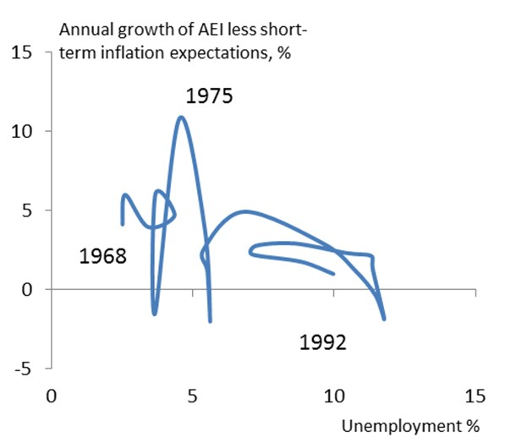Source: ONS, Bank of England and National Institute for Social and Economic Research (NIESR)

Note: NIESR inflation expectations before 1985 and 3 year implied forward inflation after.

# Chart 3 Close correlation between short-term rates and economic growth under inflation targeting

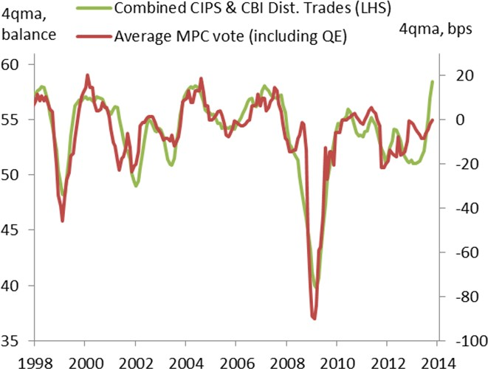

Source: ONS, CBI, Markit Economics, Bank calculations

# Chart 4a Stable wage Phillips curve, 1993- 2012 Chart 4b Close to that during gold standard

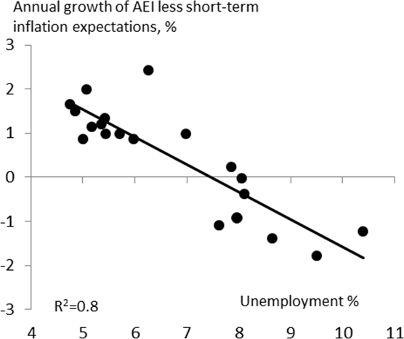 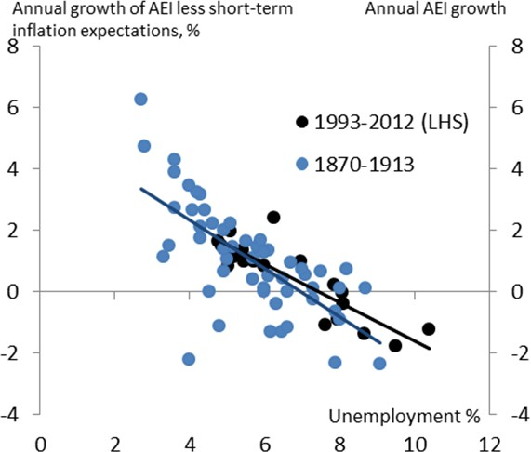

Source: ONS and Bank of England

Note: AEI until 2010 and AWE since; inflation expectations as implied by indexed gilt market.

Source: ONS, Boyer and Hatton(2002) and Hills, Thomas, Dimsdale (2010)

Note: AEI until 2010 and AWE since; inflation expectations as implied by indexed gilt market.

# Chart 5 These are the only protracted periods of stable inflation in the UK

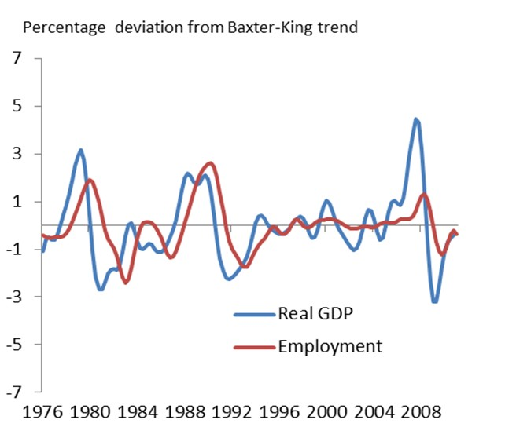**Chart 6 Cyclical movements in output predate those in employment**

Source: ONS and Hills,Thomas, Dimsdale (2010) Source: ONS and Bank calculations

# Chart 7 Supply growth stable before crisis, non- existent since

**Chart 8 Pre-crisis economy more stable under inflation targeting**

Source: ONS

* Consumer prices/ output prices, average rate of decline. Source: ONS, Eurostat and Bank of England

# Chart 9 Greater uncertainty about supply means unemployment a more valuable indicator for policy, output growth less so

Source: Broadbent (2013)

# Chart 10 Recent wage growth much weaker than expected

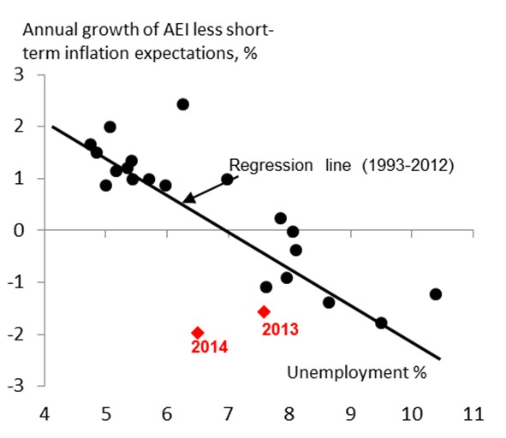

Source: ONS, Bank of England, NIESR and Hills, Thomas, Dimsdale (2010)

Note: AEI until 2010 and AWE since; inflation expectations as implied by indexed gilt market; 2014 diamond is for H1.